WEEK1
DESIGN PATTERNS
Exercise 1: Implementing the Singleton Pattern
Logger.java
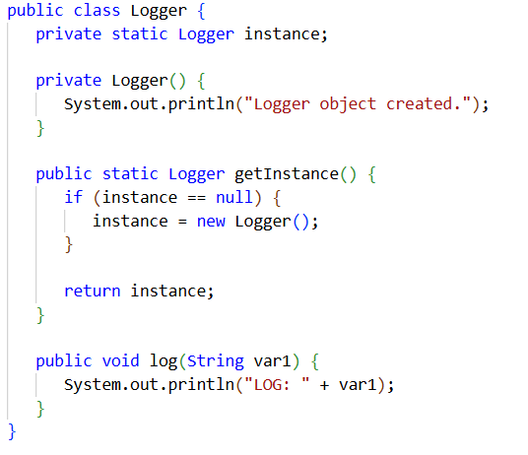
Main.java
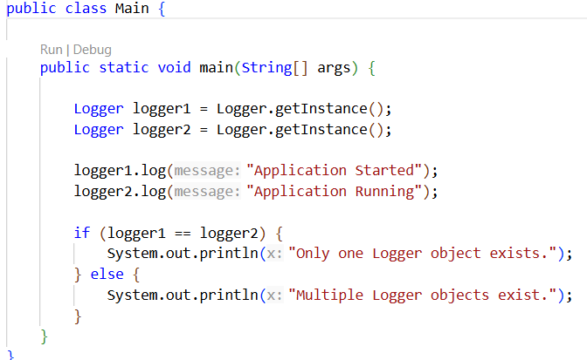
Output
